PS # ________ ENTRY FORM 2026

NAME ________________________________________________

ADDRESS ____________________________________________

______________________________________________________

PHONE _______________________________________________

EMAIL ________________________________________________

TITLE ________________________________________________

SIZE ____________________ PRICE $_____________________

PS # ________ ENTRY FORM 2026

NAME ________________________________________________

ADDRESS ____________________________________________

______________________________________________________

PHONE _______________________________________________

EMAIL ________________________________________________

TITLE ________________________________________________

SIZE ____________________ PRICE $_____________________

17th ANNUAL COMMUNITY
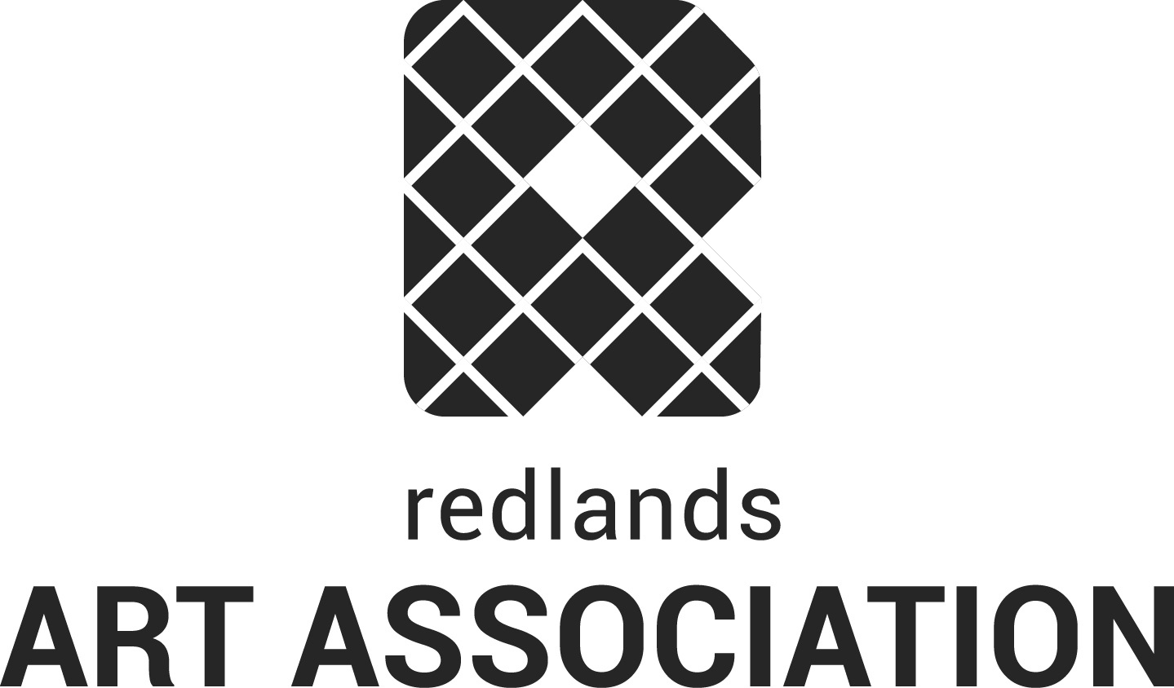
PHOTO SHOW 2026
at RAA’s Gallery & Education Center
Two Weeks ..... July 20 – August 1

Open to the public
No membership required ~ Bring up to 2 pieces

Bring photos to the gallery on Sat. July 18 from 1 to 4 pm. Entry Fee: One piece @ $5 / 2 @ $8.
Photos can be framed under glass, or printed on canvas/metal but must have hanging wire. Print name, address, title & sales price on back. 20% commission on sales.

Open House on Saturday, July 25 from 1 to 4 pm.
Show ends on Aug 1. Pick up your art from 1 to 4 pm.

Please bring friends, family, and co-workers
to see your art!

RAA Gallery & Education Center 215 E. State Street, downtown, Redlands 909-792-8435
Hours: Mon - Sat, 11 am to 5 pm

